IN HONOR OF AMERICA’S 250TH ANNIVERSARY
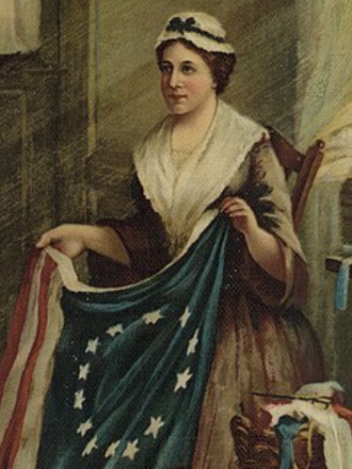
Betsy Ross
1752 – 1836
Betsy Ross is credited with stitching the first United States flag. The flag is a symbol of freedom that has since become the marker of American identity, patriotism and pride. Born Elizabeth Griscom on January 1, 1752, in Gloucester City, New Jersey, Besty was the eighth of seventeen children and was raised by a Quaker family in Philadelphia. She apprenticed under John Webster, becoming a skilled seamstress and upholsterer. In 1773, she eloped with John Ross. She got expelled from the Quaker community since John was a non-Quaker. Together, they ran an upholstery shop in Philadelphia, but John tragically died in 1776.
A widow at 24, Betsy continued running the shop, and according to legend, General George Washington, Robert Morris, and George Ross visited her in the summer of 1776. Washington showed her a sketch of a flag with thirteen (13) red and white stripes and thirteen (13) six-pointed stars and Betsy advised minor changes. This legend was made famous by her grandson William Canby in 1870. And while there is no definitive evidence, Betsy and the American flag are now inextricably linked. Throughout the Revolutionary War and for decades after, Betsy continued to make flags. In 1811, she made over 50 garrison flags for the US Arsenal on the Schuylkill River. In 1777, Betsy married a merchant sailor, Joseph Asburn and they had two (2) daughters. Joseph was captured by a British warship and died in a British prison in 1782. Betsy then married John Claypoole who was a fellow Patriot and had been imprisoned with Joseph. They had five (5) daughters and enjoyed 34 years of marriage before John’s death in 1817. Betsy retired at the age of 76, completely blind, and died peacefully on January 30, 1836, shortly after her 84th birthday.

