IN HONOR OF AMERICA’S 250TH ANNIVERSARY
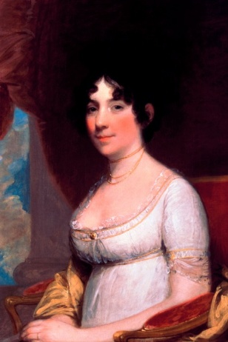
Dolley Madison
1768 – 1849
Dolley Madison, the fourth First Lady and wife of President James Madison, was known for her influence, determination, and energetic presence. A frequent entertainer, she helped shape the role of the First Lady. Born in 1768 in North Carolina, Dolley was raised in a Quaker family and married her first husband John Todd, Jr., a lawyer – though tragically, her husband and baby son died of yellow fever in 1793. Her remaining son John survived. One year later at the age of 26, Dolley married James Madison who was 17 years her senior. In 1801, President Jefferson appointed James as the Secretary of State. After President Jefferson’s wife died, Dolley helped co-host sophisticated White House events. Dolley also played a vital role in fundraising for the Lewis and Clark expedition.
When James was elected president in 1808, Dolley began an illustrious tenure as First Lady. She sponsored the first inaugural ball and became the first wife of a president to formally associate herself with a public charity project, sponsoring the first ever home for orphaned girls in Washington D.C. When British forces invaded Washington and set the White House on fire on August 24, 1814, Dolley famously ordered the saving of historic documents, silver, and art (including a portrait of George Washington). Dolley enjoyed playing cards, dipping snuff, and embracing fashion trends. After James Madison’s death, Dolley remained a prominent figure in social and political circles, and was the first private citizen to send a message through telegraph. In 1849, at age 81, Dolley Madison died.

