IN HONOR OF AMERICA’S 250TH ANNIVERSARY

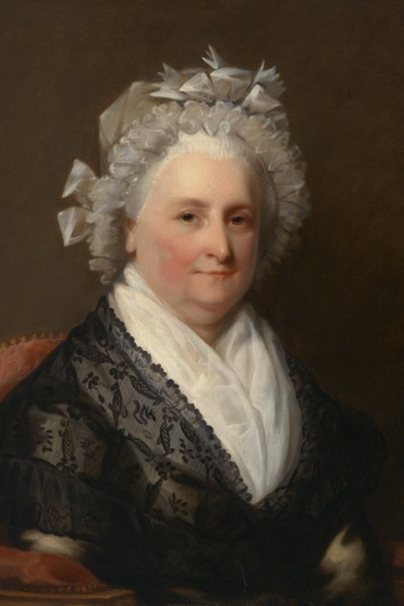
Martha Washington 1731 – 1802

Martha was known as the “First Lady” of the United States as well as for her personal strength, devotion to her husband, and patient resolve during and after the war.
She learned to read and write at a time when many women did not. In 1759, she married her second husband George Washington. Martha was about five feet tall and George stood over six feet and two inches tall, but she made up for petite stature through her unflappable spirit.
She spent the brutal winters of the Revolutionary War at the front with her husband. In addition to providing invaluable support to him, she mended socks, raised money for supplies, and boosted moral among the troops. During this time, she lost her last living child, Jack, when he died of camp fever.
George Washington was elected the first president and they were known as America’s first couple. Martha set important social and political precedents in New York and Philadelphia.
After President Washington died, Martha freed his slaves as was his wish. America’s first couple are buried side by side at Mount Vernon.

