IN HONOR OF AMERICA’S 250TH ANNIVERSARY
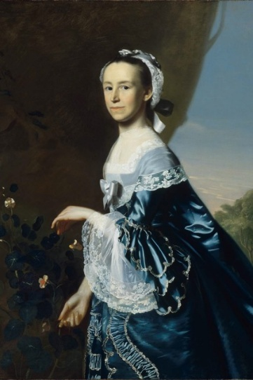
Mercy Otis Warren
1728 – 1814
Mercy Otis Warren was known as the “Conscience of the Revolution,” and described as perhaps the most formidable female intellectual in 18th century America. She was a poet, historian, and playwright, she believed in the revolution, and played an integral role in capturing, shaping, and moving the cause forward. She was born in 1728 in Barnstable, Massachusetts. Mercy grew up in household where her intellectual and academic pursuits were encouraged, which was unusual for women at the time. She married James Warren, a politician, in 1754, and they had five sons. Patriotic, and writing anonymously, Warren published her satire, The Adulateur, and two other plays (Defeat & The Group) each denouncing the British. She supported the Boston Tea Party and boycotts of British goods. In 1790, using her real name, Warren was the third woman to publish a book of poems. She also published History of the Rise, Progress, and Termination of the American Revolution. Mercy’s work comprehensively captured the history leading toward Revolution. Hers was one of the first nonfiction books published by a woman in America. She also denounced the institution of slavery and as a Anti-Federalist, she took a strong stand against ratification of the Constitution. At the age of 86, Warren died in October 1814, in Massachusetts; leaving behind a legacy as a bold woman undeterred in telling the truth.

