
Passport to the Township of Mansfield

Welcome to the Township of Mansfield, Warren County’s largest geographical township. Our unique combination of mountain views, tranquil streams, the scenic Musconetcong River, and convenient shopping make this a desirable community to raise your family or retire in an enjoyably, slow-paced environment.

In this booklet, you will find a list of important township services, organizations, places of worship, contact information, etc. It is our hope that you will use our passport as a guide to learning all about the Township of Mansfield.

Whether moving into the Township for the first time, moving back, or being a life-long resident, the Passport will serve as a “Township of Mansfield 101 Guide” and will introduce you to all the Township has to offer.

Mansfield Township Geographical Facts

Do I live in the Township of Mansfield?
Yes! The Township of Mansfield is comprised of five (5) sections. There is no actual Mansfield mailing address or zip code.
Resident mailing addresses include: Hackettstown, Port Murray, Oxford, Great Meadows or Washington
Shopping – All the strip malls on Route 57 are in Mansfield Township, but have a mailing address of Hackettstown; most people assume they are in Hackettstown.

Port Murray – The Municipal Building, Police Department, and Mansfield Elementary School are all located in the Port Murray section of Mansfield on Port Murray Road.


To the Citizens of the Township of Mansfield
Every Township of Mansfield success story has resulted from the enthusiasm, suggestions, and ideas of its citizens. The willingness of our citizens to get involved and to participate in the affairs of the Township has enabled the Township of Mansfield to become a very special community.
So that we may continue to reflect the aims and the desires of our citizenry, we welcome and strongly recommend your participation in Township Committee meetings and other public forums. With your continued interest and assistance, the Township of Mansfield will remain a leader in municipal achievements and responsiveness.

TOWNSHIP COMMITTEE:
Mansfield Township is governed by a Committee form of government. The Township Committee remains the backbone of the municipality’s government. Voters elect at-large, the Township Committee comprising of five members. The elections are partisan and the committee members serve staggered three-year terms. The Township Committee elects the Mayor and Deputy Mayor for a one-year term. The Mayor serves as chair of the Township Committee and has powers vested in the Mayor’s office by general law. In the event of the Mayor’s absence, the Deputy Mayor has the authority to step in and act on the Mayor’s behalf.

COMMITTEE MEETINGS:
Township Committee meetings are held on the 2nd & 4th Wednesday of each month at 7:30 pm. Audience participation occurs during each meeting. Both meetings are held at the Municipal building located at 100 Port Murray Road, Port Murray. Discussion topics may include allocation of funds, award of bids, contracts, budget hearings and any ordinances which have been introduced by the Committee. All meetings are held in strict compliance with the Open Public Meetings Act of New Jersey.

Citizens are encouraged to attend Township Committee meetings and are welcome to appear before the Committee. Agendas are available both online and outside the Township Clerk’s office the Friday before each Committee meeting. ALL meetings are open to the public, except for Executive Sessions.

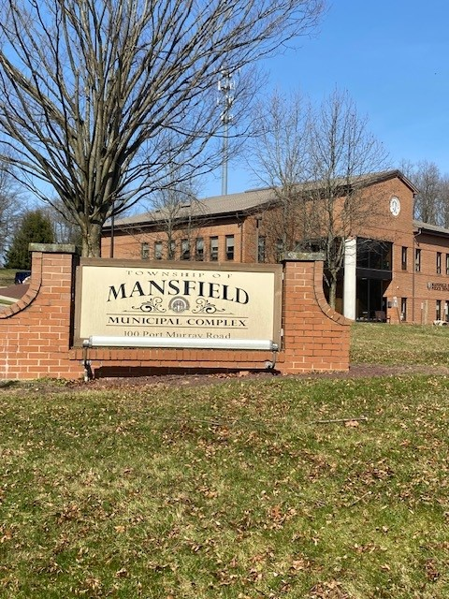

Government Offices of the Township of Mansfield
Township Clerk
The Township Clerk’s office is entrusted with numerous and diverse duties. By law, it acts as secretary to the Governing Body and liaison between the governing officials and the residents. The Township Clerk is the custodian of the Township’s records and is responsible for the retention of them. The office of the Township Clerk serves as the licensing official for dogs, liquor licenses, solicitors, raffles, bingos, towing, junk dealers, and temporary food truck licenses. The Township Clerk is the chief administrative officer of all municipal elections and is the chief registrar of voters in the municipality. The Township Clerk also serves as the Township’s Registrar of Vital Statistics and issues death, marriage, and birth certificates.
908-689-6151 Ext. 128 clerk@mansfieldtownship-nj.gov

Dog & Cat Licenses
Dog licenses are obtained at the Clerk’s Office. Applications can be found on the Clerk’s page on the Township website at www.mansfieldtownship-nj.gov. Proof of rabies vaccination must be valid through November of the current year and should accompany the application form. Licensing fees and information are on the form. For questions, please contact the Clerk’s Office at 908-689-6151 Ext. 100 or 128.

Cats are not required to be licensed. We do encourage residents to update their rabies vaccines for their cat’s health.

Mansfield Township offers an annual Rabies Clinic usually held in mid to late November for both dogs and cats. This event is held free of charge and open to all.

Finance Office
The Chief Financial Officer (CFO) is responsible for the administration of the Township fiscal affairs. Their duties include the management of various operating, capital, and trust funds; budget preparation; collection of revenues; budgetary accounting; payroll; disbursements; and investments of township funds. In the Township of Mansfield, the CFO also holds the position of Qualified Purchasing Agent.
908-689-6151 Ext. 127 cfo@mansfieldtownship-nj.gov

Tax Collector
The Tax Collector (CTC) is responsible for the billing, collection, and recording of all taxes, and special assessments levied upon properties in Mansfield Township. Tax bills include County, Library, Schools, (regional & district), open spaces and municipal taxes. The Tax Collector is required to hold a yearly tax sale for previous year unpaid taxes.
908-689-6151 Ext. 115

Tax Assessor
The Tax Assessor maintains and updates assessment records, tax maps, sales analysis for equalization purposes, processes applications for exemptions and deductions including veterans, senior citizens, disabled persons, and other legally tax-exempt properties, and defending assessment appeals filed against the Township.
908-689-6151 Ext. 117 tax.assessor.nj@gmail.com

Construction Department
The Construction Department controls all matters concerning the construction, alteration, addition, repair, removal, demolition; the use and occupancy of all existing and proposed buildings and other structures in the Township, and issues all required permits. The Township’s Construction Department is serviced by Washington Township, Morris County through a Shared Service Agreement.
908-876-4711 Option #2 building@wtmorris.net

Zoning Officer
The Zoning Officer’s responsibility is to ensure that any proposed use, construction, or alteration is permitted use in the zoning district and conforms to the zoning ordinance in area and setbacks. Before an applicant can undertake a project, a zoning permit must be applied for and obtained. The permit process consists of the application requesting the use or proposed work with a survey or sketch of the property, and the applicable fee.
908-455-2957 zoning@mansfieldtownship-nj.gov

Township Engineer
The Township Engineer provides technical services to many departments such as the Land Use Board and Dept. of Public Works. State law requires that municipal infrastructure improvements such as roads, catch basins, culverts, etc. be designed and reviewed by a licensed professional engineer. The Township Engineer also reviews and inspects storm water systems, review of some Land Use Board applications, and municipal infrastructure improvement projects.


Department Of Public Works
The Public Works Department is responsible for maintaining the Township’s infrastructure and public facilities. Any issues observed with roads or public buildings should be brought to the attention of this office. Common examples are pot holes, graffiti, missing street signs, blocked catch basins, blocked sight distance at intersections, down trees/branches on the roadway, etc.
908-689-6151 Ext. 312 dpw@mansfieldtownship-nj.gov

Trash Removal Companies


The Township does not provide curbside trash pickup. You may choose one of the following companies that suits your needs to remove trash and every day recycling items.

Sanico 908-475-3300
Global 908-684-8813
LMR 908-454-4550
Waste Management 908-852-2234

Leaf/Brush Pickup
The Township does not pickup curbside leaves, grass, or brush. Please contact a landscape company to remove your greenery or set up a compost pile on your property.

Snow Removal
Garbage and recycling containers, portable basketball hoops, sports equipment, and other items must be kept off roadways to enable efficient snow plowing.

Bulk Pickup
The Township does not provide Bulk Pickup. Please contact your trash hauler to remove large items.

Warren County Recycling Center
Warren County District Landfill – 500 Mt. Pisgah Avenue, Oxford; 908-475-6532
Open Monday-Friday 7:00 am through 2:30 pm; Saturday- 7:00 am through 11:00 am

Cardboard Recycling
Available 365 days at the Municipal Building. Please breakdown boxes and place them in the container on the side of the building near the Police Station at 100 Port Murray Road, Port Murray, NJ.

Free Town-Wide Paper Shredding Event
Usually held in October at the Department of Public Works, 1710 Rt. 57, Hackettstown, NJ. Date and time will be posted in the next newsletter and on the Township website home page under Mansfield News at www.mansfieldtownship-nj.gov. For more information, please contact JoAnn, Recycling Coordinator, at 908-689-6151 Ext. 116.

Electronic Waste, Scrap Metal, Large Rigid Plastics & Mercury Switch Thermostats Event
Held in November at the Department of Public Works Garage, 1710 Rt. 57, Hackettstown, NJ. Information will be posted on the home page of the Township website under Mansfield News at www.mansfieldtownship-nj.gov.

Mansfield Township Newsletter
The Township Newsletter will be included with your property tax bills. Extra copies are available in the Lobby or the Municipal Building. This correspondence includes notifications for community events as well as important Township information.

Mansfield Township Calendars
Free calendars are available at the Municipal Building from November – January. Photos are submitted by residents. Each month has a picture of a landmark or interesting area of Mansfield. It has become a popular item that residents look forward to each year.
Township of Mansfield Emergency Services

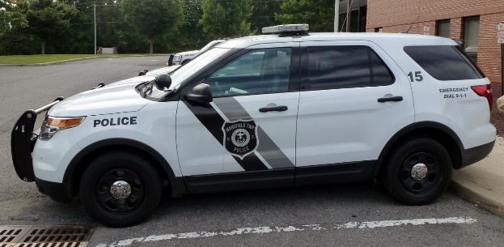
POLICE DEPARTMENT
The duties of the Mansfield Township Police Department are that of which are prescribed by the laws of the State of New Jersey, the ordinances of Mansfield Township, and the rules and regulations prescribed by the Police Department and approved by the Township Committee.
Emergency 9-1-1 Non- Emergencies 908-689-6222
police@mansfieldtownship-nj.gov

FIRE DEPARTMENT
Mansfield Township is protected by the Mansfield Township Fire Company and the Tri- County Fire Department. The Fire Departments respond to all fire alarms and various motor vehicle accidents.
Emergency 9-1-1
Mansfield Township Fire Company 324 Main St., Port Murray 908-689-5285
Tri-County Fire Department 1720 Route 57, Hackettstown 908-852-1310

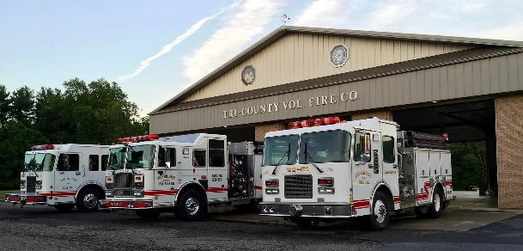
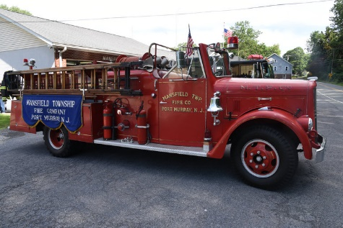

EMERGENCY MEDICAL SERVICES
Independence First Aid Squad is a hybrid organization which consists of both volunteer and career personnel. They provide Emergency Medical Services to Independence Township, Liberty Township, and Mansfield Township 24/7.
Emergency 9-1-1
Independence First Aid Squad 3 Regina Lane, P.O Box 137, Great Meadows 908-637-4477
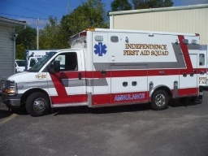

WARREN COUNTY RAVE ALERT SYSTEM

Community and Weather Alerts – (Similar to a Reverse 911 System) No cost to residents. Sign up at https://warrencountynjdps.com. Depending on provider and phone service, message and data rates may apply.


MANSFIELD TOWNSHIP MUNICIPAL COURT
Mansfield Township Municipal Court is a shared service court serving Mansfield Township, Oxford Township, Washington Township, and the Borough of Washington. The Municipal Court hears cases involving motor vehicle violations, municipal ordinances, disorderly persons, and other quasi criminal matters. Court is held the 1st and 3rd Tuesday of each month.
908-689-6151 Ext. 118

SCHOOLS

Mansfield Township Elementary School
50 Port Murray Rd., Port Murray
908-689-3212
www.mansfieldtsd.org

Kindergarten through 6th Grade

Warren Hills Regional Middle School
64-66 Carlton Ave., Washington
908-689-0750
www.ms.warrenhills.org
7th & 8th Grade

Warren Hills Regional High School
41 Jackson Valley Rd., Washington
908-689-3050
www.hs.warrenhills.org
9th through 12th Grade

Warren County Technical School
1500 Route 57, Washington
908-689-0122
www.wctech.org
9th through 12th Grade

RECREATION PROGRAMS
Soccer, football, softball, cheer, basketball, field hockey, and clinics are available for children grades Kindergarten through 8th Grade. For more information, visit www.mansfieldtownsip-nj.gov .



MANSFIELD SENIORS
Seniors (55+) are invited to attend meetings on the 2nd Tuesday of each month at the Mansfield Fire Company. Speakers present informative topics while you socialize and enjoy refreshments. Day trips, an annual picnic, and annual holiday luncheon are offered to members. For information, email Carol McKevitt at mansfieldseniors@mansfieldtownship-nj.gov or call 908-850-9320. Yearly activities are listed on the Seniors’ page on the Township website at www.mansfieldtownship-nj.gov.

MANSFIELD TOWNSHIP BOARDS/COMMITTEES

Environmental Commission- An advisory commission to the Township Committee on environmental matters in the Township. Meetings are held the 2nd Tuesday of the month at 7:30pm.

Land Use Board- The Land Use Board functions under the authority of the Municipal Land Use Law of New Jersey. The Board charts the future of the Township by examining existing and potential development in the Township. Meetings are held on the 3rd Monday of the month at 7:30pm.

Recreation Committee- The Recreation Committee is an all-volunteer board that runs youth programs for basketball, cheerleading, field hockey, flag football, soccer, and softball. Volunteers are welcomed for board activities as well as coaching positions. recreation@mansfieldtownship-nj.gov

Green Team- The Green Team’s mission is to improve our quality of life and keep Mansfield Township clean and green. jf@mansfieldtownship-nj.gov

Flea Market & Craft Fair
– Annual event sponsored by the Green Team, held in the spring. Dates and times will be posted on the home page of the Township website under Mansfield News at www.mansfieldtownship-nj.gov. For information, contact 908-689-6151 Ext. 116 or 100.



Points of Interest in Mansfield Township

Hackettstown Airport – Private airport – Airport Road

Rockport Train Wreck Memorial – Hazen Road, Hackettstown – 50 people perished in the 1925 wreckage that devastated the village of Port Murray. A documentary video can be viewed by visiting www.johngeneral.com/extra1104 that details the horrendous event.

Xfinity Store by Comcast – Phone store and Cable/Internet Equipment drop off – 155 Port Murray Road, Port Murray, NJ, 800-266-2278

Cinepolis Luxury Cinemas – Dine-in movie theater – 1965 Rt. 57, Hackettstown, NJ, 908-852-5960

Parks

- Hector A. Caferatta, Jr. Park – Port Murray Road – Tennis courts, ball fields, and walking park
- Kensington Park – Winchester Avenue – Tennis courts, ball fields, and walking park
- Port Murray Park – Warren County Park- Hoffman Road – Hiking trail

Churches

- St. Theodore Roman Catholic Church – 855 Rt. 57, Port Murray, NJ 908-689-8318
- Abundant Life Church - 21 Cherry Tree Ben Road, Port Murray, NJ 908-689-3272
- Rockport Presbyterian Church – 395 Rockport Road, Port Murray, NJ 908-852-6515
- Iglesia Cristiano Tabernaculo de Adoracion – 720 Rt. 57, Port Murray, NJ 484-426-1535
- Skylands Unitarian Universalist Fellowship – 1811 Rt. 57, Hackettstown, NJ 908-509-1617
- First Baptist Church of Anderson – 150 Jackson Street, Port Murray, NJ 908-689-0409
- Hillcrest SDA Church – 590 Rt. 57, Port Murray, NJ 908-689-7774

Shopping

While anchor stores are listed, many other stores are housed in these malls:

- Mansfield Commons I & II – 1885 Rt. 57 – Wal-Mart, Kohls, Marshalls, Starbucks, Aspen Dental
- Riverside Plaza – 1892 Rt. 57 – Riverside Health & Fitness, Just Made Bakery, Asia Kitchen
- The Shoppes at Mansfield – 1930 Rt. 57 – Tap House Grille, Moe’s Southwest Grill, Primo’s Hoagies
- Mansfield Plaza – 1965 Rt. 57 & Allen Road – ShopRite, CVS, Cinepolis Luxury Cinemas
- Mansfield Village Square – 2045 Rt. 57 – Home Depot, Weis Markets, Staples



Warren County
Libraries
Catherine Dickson Hofman Branch
4 Lambert Rd., Blairstown
908-818-1280

cdhbranch@warrenlib.org

Southwest Branch
404 Route 519, Phillipsburg
908-818-1280
swbranch@warrenlib.org

Richard D. Gardner Branch (Headquarters)
2 Shotwell Dr., Belvidere
908-818-1280
hqbranch@warrenlib.org

Northeast Branch
40 US Hwy. 46 West, Independence Township
908-818-1280
nebranch@warrenlib.org

Warren County Clerk’s Office
County Clerk Holly Mackey
Warren County Courthouse
413 Second St., Belvidere
908-475-6211

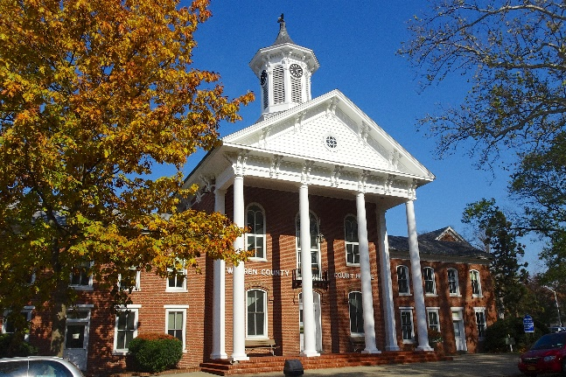
Warren County Health Department
700 Oxford Rd., Oxford
908-475-7960

Warren County Election Board
202 Mansfield St., Belvidere
908-475-6313
www.warrencountyvotes.com
warrenboe@co.warren.nj.us

